1. UML Class Diagram Overview
The UML Class Diagram for the AI Hotel Reservation System defines the structural design of the system, showcasing classes, their attributes, methods, and relationships. This diagram serves as a blueprint for implementing the system's functionality while ensuring modularity and scalability.
2. Key Classes & Functionality
- Search_Engine
  - Purpose: Handles hotel searches and AI-driven recommendations.
  - Key Methods:
    - Search(keyword, destination, dates, filters): Retrieves hotel listings.
    - ProvideSuggestions(input): Generates AI-powered recommendations.
- Hotel & Deal
  - Hotel: Stores hotel details (name, location, rating) and manages API data fetching (FetchDetailsFromAPI).
  - Deal: Manages promotional discounts and validity checks (ApplyToHotel, CheckValidity).
- User & Notification
  - User: Manages user profiles, authentication (Register, Login), and bookings (ViewBooking, CancelBooking).
  - Notification: Handles alerts (SendNotification, MarkAsRead) for bookings and promotions.
- Admin_Dashboard
  - Purpose: Provides administrative controls for managing users, reservations, and pricing.
  - Key Methods:
    - ManageUsers(): Edits user accounts.
    - EditReservation(Booking_id): Modifies bookings.
- Booking & Room
  - Booking: Tracks reservation details (dates, price, status) and supports modifications (ModifyBooking).
  - Room: Manages room availability and pricing (BookRoom, CheckAvailability).

3. Critical Relationships
- Associations:
  - User ↔ Booking: A user can have multiple bookings.
  - Hotel ↔ Room: A hotel offers multiple room types.
- Dependencies:
  - Search_Engine → Hotel: Fetches hotel data for searches.
  - Admin_Dashboard → Booking: Modifies reservation details.

4. Design Advantages
- Modularity: Isolates features (e.g., search, booking) for independent updates.
- Extensibility: Easily add new methods (e.g., payment processing) without disrupting existing classes.
- AI Integration: The Search_Engine and AI Recommendation classes enable seamless personalization.
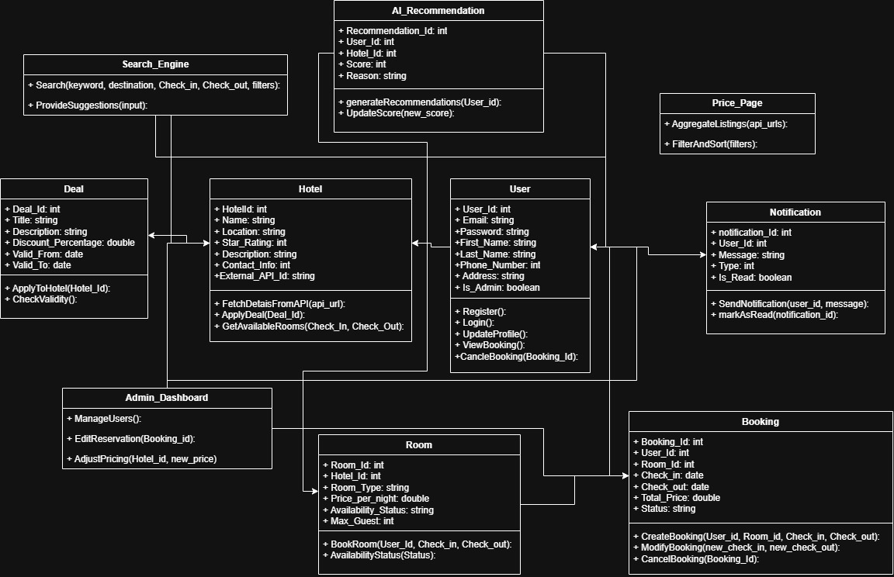
Figure 1: This UML design aligns with Scrum’s iterative approach, allowing incremental feature development while maintaining a clean, maintainable codebase.

